Unit of study: COMP5216 Mobile Computing

Proposed assignment name: Quiz For Information Technology

Assignment will be completed by: Zhiliang Wang (460094203)

Abstract:

This app is going to be designed as a quiz of learning basic concepts.

The purpose of this project is to build a notes-taking app. This project proposal aims to clarify the idea and set the schedule. It consists of five sections: Introduction, Objective, Related Work, App Storyboard and Schedule. In the Introduction and Objective, the motivation of this project and the purpose of the final app will be discussed. Pros and cons of five famous notes-taking app will be covered in Related Work. Also, the storyboard of the final app will be explained in detail in App Storyboard. In the end, the schedule of this project will be displayed.

Quizzes improve or expanding one’s knowledge of things, either general or in specific area

* Quizzes are designed to promote, a fun way to study and in the process help improve one’s general knowledge
* Quiz competitions enables students to think from different angles or simply ‘to think out of the box’
* It promotes a healthy debate amongst participants in order to learn from each other
* Quiz competitions are used in Schools and Universities to aid in language development and in particular subject areas of study
* Some educational institutes use it as a brief assessment or tool to measure the growth in the knowledge, abilities and / or skills of their pupils either on a general level or restricted to specific fields for instance, science, maths etc
* Being fun to participate in but with a competitive element
* Provoking discussion and healthy debate amongst participating players / teams
* Making new friends, from different cultures at times
* Quiz competitions even help build the student’s soft skills

Contents

**Background & Significance**

As a rookie of IT domain. I felt it was so hard to handle with the basic concepts of IT programming languages such as Java, python nodeJS and so on as well as some protocols and principles in IT domain. I was a civil engineer before I came USYD, but I am so interested in learning new things in new area of IT. A quiz in game style that can also be called a mind sport can help individuals or spur them to attempt to answer questions posed to them correctly, in order to build confidence and motivation for learning boring theory.

Comparison with other similar IOS apps

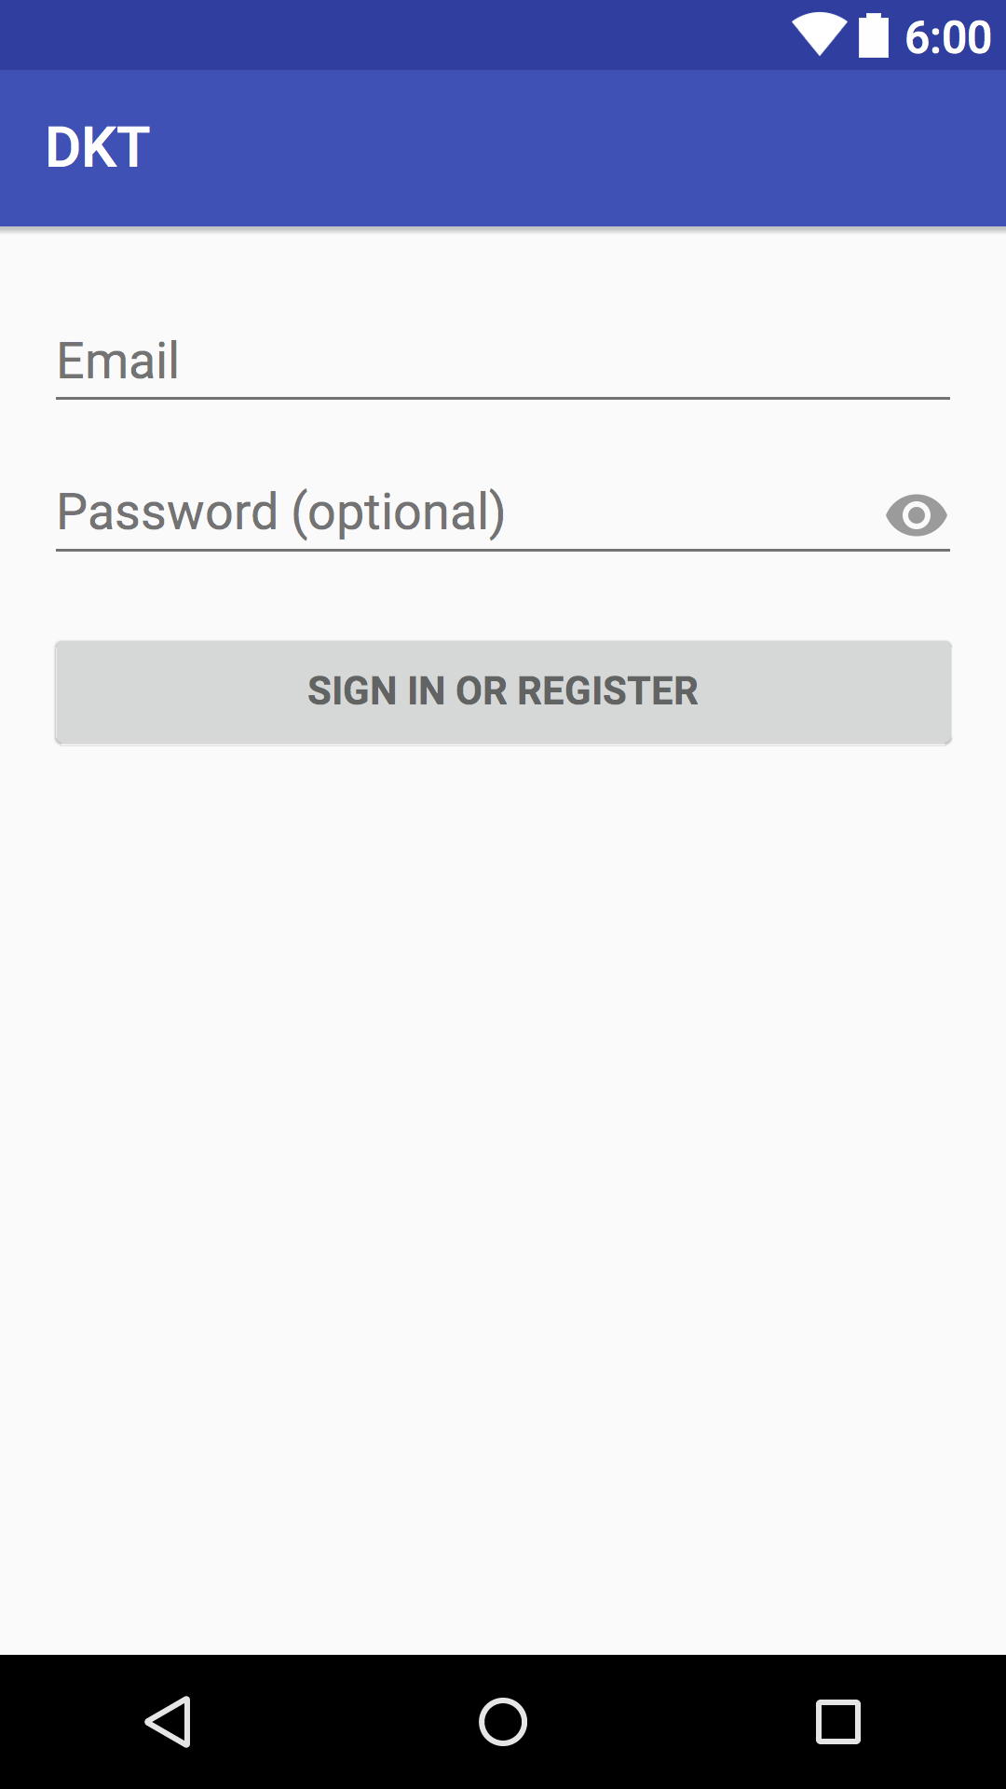Related work about DKT practices on mobile platform

When the users have studied for the test, there is a free online practice test on the government website for them to simulate the real test they were preparing for, like Service NSW DKT Practice Test. However, as a significant step of getting driver licenses, the official practice test has several drawbacks not only involving functional aspects but also related to the user interface aspects.

First of all, the official DKT practice test application only supports iOS system. Moreover, it is essentially identical to the online practice test on web pages, which means the user interface of that is not suitable for the mobile platform. It not only breaks the design rules of applications among all the platform but also carries a bad user experience.

Secondly, the practice test can only release 45 randomly questions each time, however there are nearly 600 questions in the DKT question bank, users who studied for the test can only memorize all the questions on the PDF file which is provided on the official website, there is not a study system in the application which for helping users to study the question bank or the guidebook. This is exactly a bad experience for the users which are going to take a DKT but can not use the practice test application to cover all the questions they probably meet in the real test.

At last, although there is a rider DKT practise application has released on Google Play (Android Application market by Google), but there is only English supported in this application. Compare with the real test, there are several languages supported such as French, Spanish or Chinese. There is also a lack of review system in this application, it can be improved better with more functional blocks for increasing the users’ stickiness.

As the analyzation above, it is necessary to develop an application for the driver test studies more professional, especially on the Android platform. The Android has taken at least more than six times than the other platform in the worldwide smartphone OS market share statistics in last three years by IDC (International Data Corporation). Requirements of the Android application have never been dropped down.

Solutions

DKT is a program on the PC for the road rules knowledge test, each time when users attend the test, the program will select 45 questions randomly from the question bank which includes 600 questions as candidate questions.

In the DKT real test, the questions include two scales of sections. In the first part of the test, candidates are required to answer 15 general knowledge questions, and get at least 12 correct answers to continue, then 30 road rules and safety questions (including traffic sign) are permitted at most one incorrect. If a candidate gets four questions wrong in the general parts or gets two questions wrong in the road safety section, the test will be automatically terminated. In addition, there is no time limit for completing the test.

For achieving the aim of practice, there are four core sections in our application, which are DKT Practice Test, DKT Question Bank, My Collection and More Information. The combination of these parts has covered the whole process of studying diver knowledge among learning, testing and reviewing. We will discuss more details about these four parts below.

Functions Overview

* **Login:**

Permiting users login their account using correct username and password, for attracting more users to use the application more effectively, users can skip login and enter into the home page directly, however, if they are going to use the function of question collection, they have to login successfully first.

* **Sign up (Register):**

Allowing users register a new account verified email address or phone number with a password, the strength of the password will be considered. The users also need to provide a nick name. Entire users’ data will be stored in the database with encryption. If the user signs up successfully, it will sign a successful hint then turns to the home page with login statement automaticly, if not it will sign a hint for reminding users about wrong with username and password.

* **Forgot password (Password retrieve):**

The users who use this function can find their password back through setting a new one, the verification codes from the email address or SMS from their phones that have registered before are required. There is also a ‘resent’ button for sending the verify email addresses or phone numbers again. If the verification code is correct, the user can set a new password then confirm it.

* **DKT Question Bank:**

Users can use this function to memorize the correct answers to all the questions in the question bank, all questions have marked the correct answer, these questions are all possibly occurring in the real test. In this function, users can also collect the questions to the ‘My Collections’ list which they would like to mark and review these questions later. When users are going to quit the question bank, there will be a hint that signs two selections, which check the collection list directly or back to the home page.

* **DKT Practice Test:**

Users can use this function to simulate the real test, the form and layout of the function will be identical to the real test. Users will select the language and vehicle type first, and then start to answer the questions, At the beginning of all the questions, there is an option button for selecting to watch the introduction of the test or not. In the test content, users will tick one answer and then click the ‘next question’ button, if the answer is correct, a highlight checkmark will occur, otherwise, a highlight of incorrect sign will appear and show the correct answer with a checkmark. Users can use ‘Exit’ button to quit the test anytime. When users have finished all the 45 questions, a mark sheet while released including the test mark and test result (Fail/Pass), which means although users will not pass the current test, the test will not be terminated for the purpose of allowing users have more experience on handling the test.

* **My Collection:**

Users can use this function to review the questions they marked before, if a user has not login, it will turn to the login function first, which means that users must use collection function after login their account. The data of collections will be stored with the users’ account in the database.

* **More Info:**

There are several other functions combine in More Info page. Click the More Info botton on the home page, then it will turn into a new page with all the other useful items. Such as, booking a test, which will turn to the web browser to book a test, using map function can also find the nearby test place or driver training school. There are also some contact link like facebook, twitter or email on this page for supporting the ways to feedback.

Flow char diagram

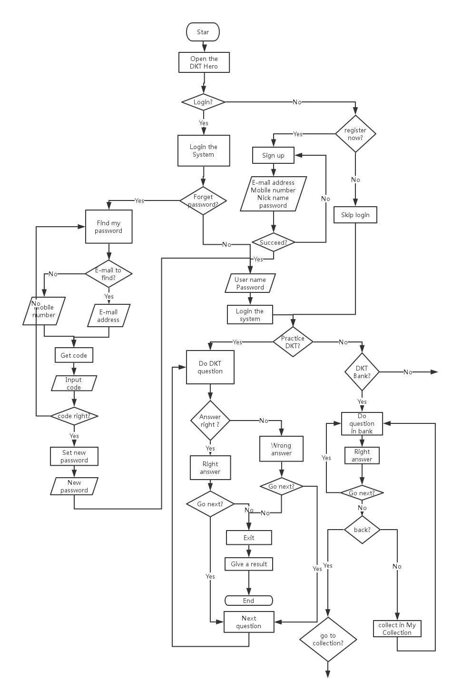

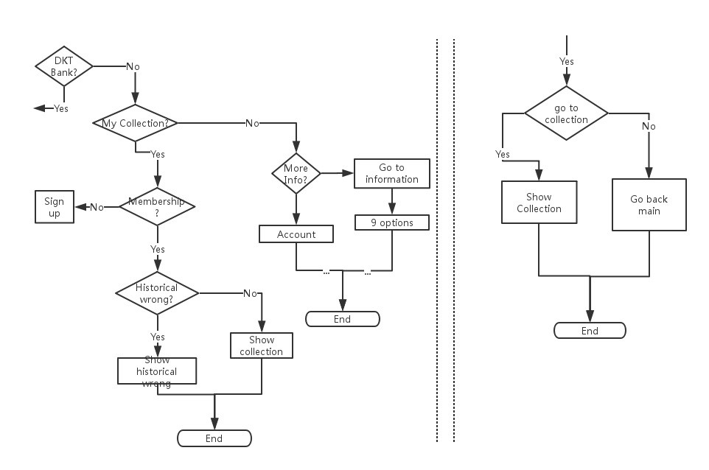The diagram above shows the implement and demonstrate process of using the application.

Design draft

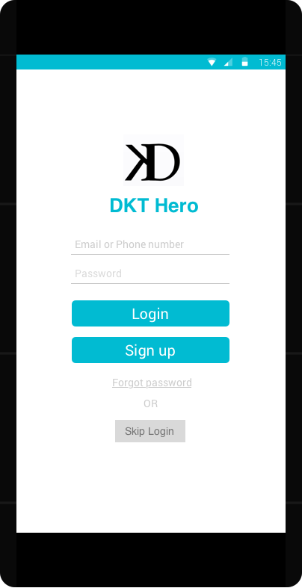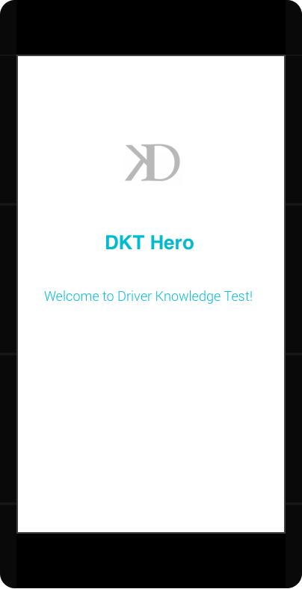

Figure 1 Welcome page

Figure 2 Login page

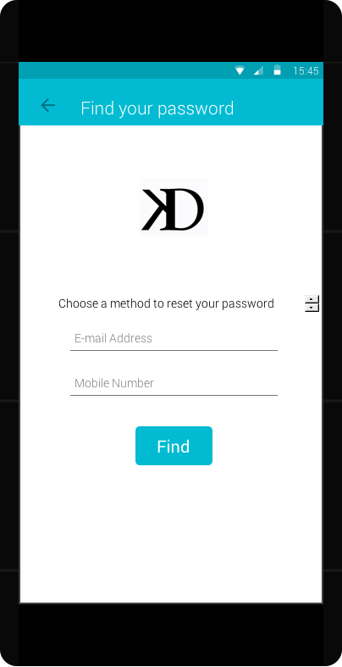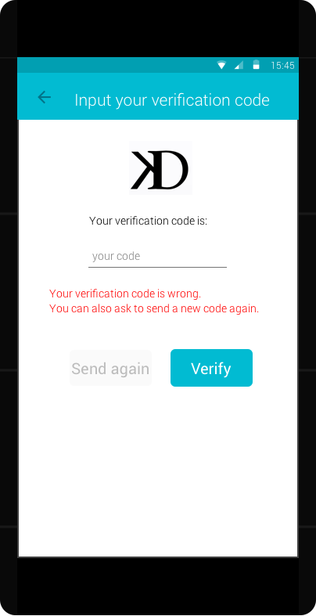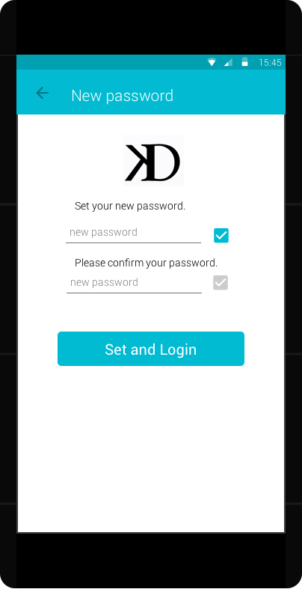

Figure 3 Find password page

Figure 4 Verification page

Figure 5 Reset password page

Figure 8 Model chosen page

Figure 7 Language chosen page

Figure 6 Home page

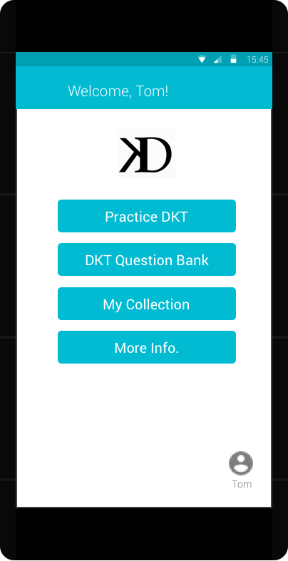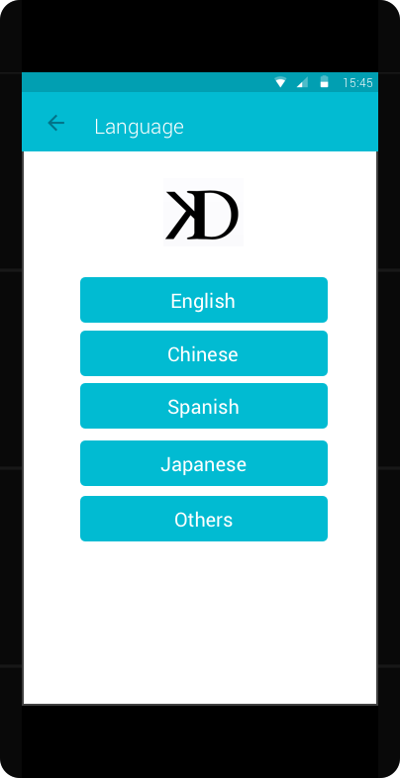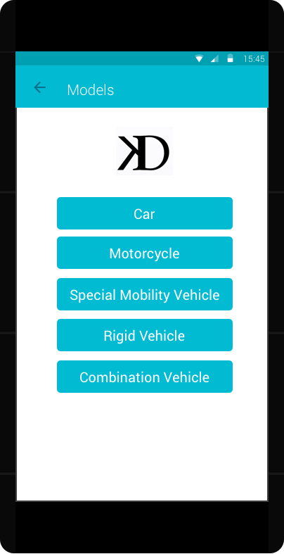

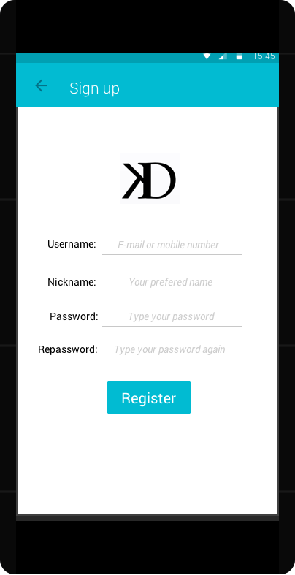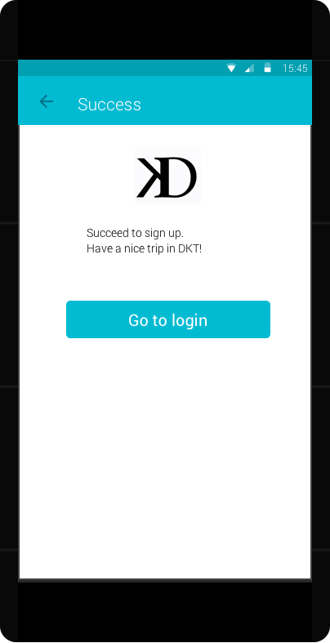

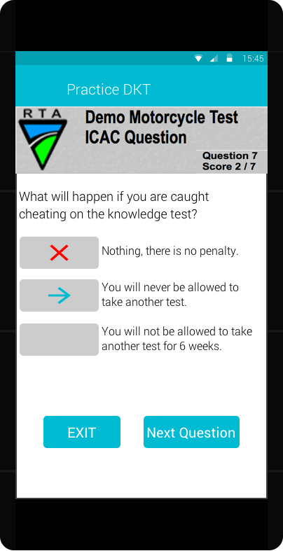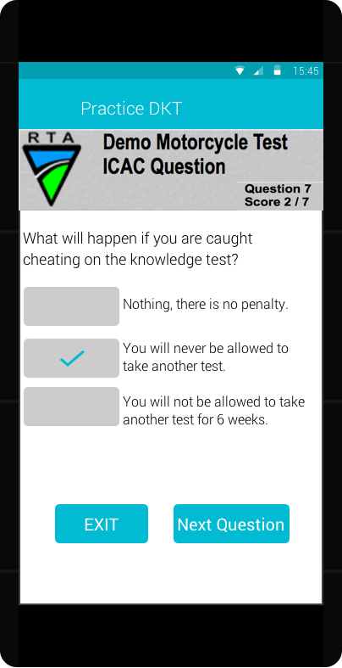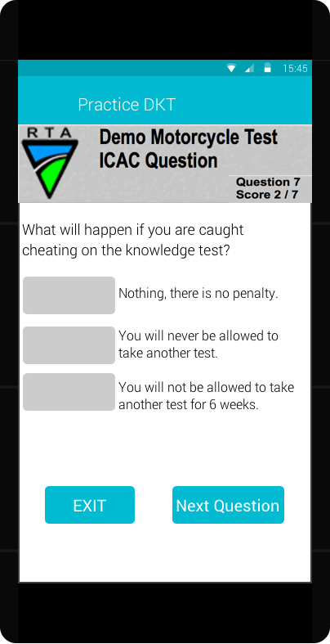

Figure 11 Practice Test page

Figure 12 incorrect answer page

Figure 13 correct answer page

Figure 10 login success page

Figure 9 Register page

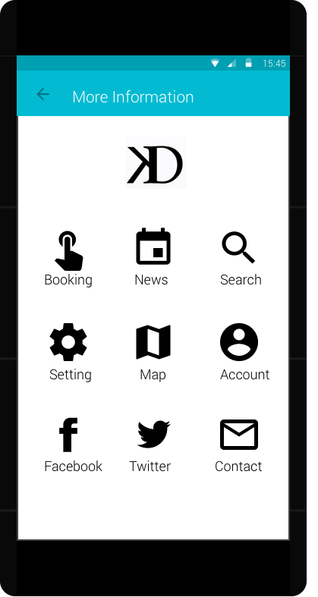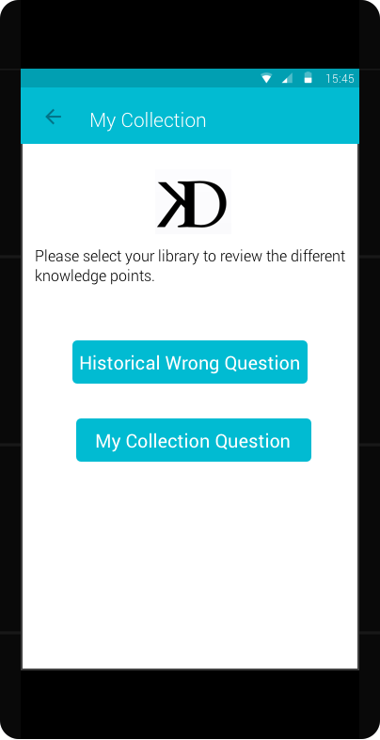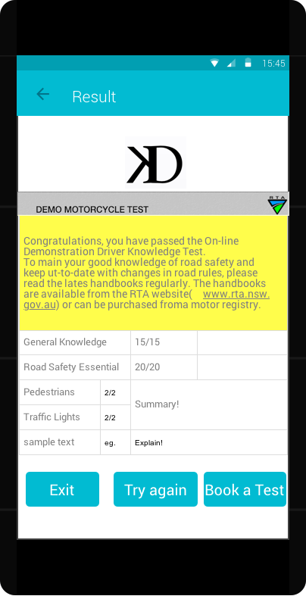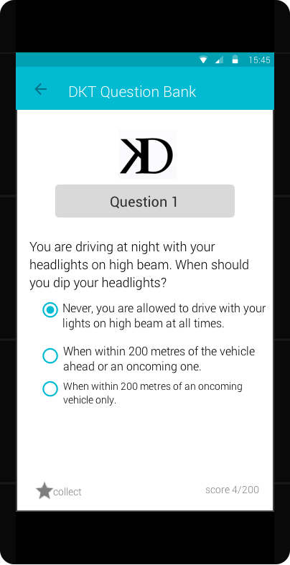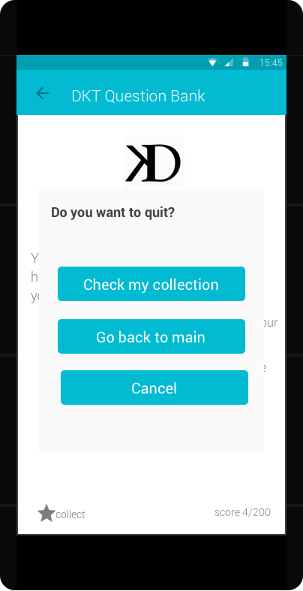

Figure 18 More information page

Figure 17 My Collection page

Figure 14 Test Result page

Figure 15 Question Bank page

Figure 16 Bank quit page

Techniques and schedule

We use Android Studio 2.0 for the main developing tool, we are planning to understand the configuration of gradle file and main components such as Activity, Intent and Service in the first month, then develop some basic events in our design. After that we are going to learn about the data storage, such as read Assets and raw files, Sharepreferance, using SQLite or Azure to store the data and some knowledge about XML or Json type. During this process, we would like to handle some issues about data storage and transmission. At last, we are going to consider about the UI design and the using of open source library including the using of a third party SDK or API, as well as some simulation test techniques. We have separated our task as Lida Guo will handle the login and register functions, and Jiyang Li will deal with the test system and question bank system especially the database design section. After that, we will discuss the rest of the project, such as the using of SDK and UI design.

Reflection and outlook

In this project, we found many useful resources on the websites. The most authority one is the official document on developer.android.com. We have also learned some knowledge and personal practice experience about Android developing from many blogs any other Android developers, They are very helpful. We have read several chapters of two books, one is “Android design patterns: interaction design solutions for developers” written by Nudelman, Greg, we have learned some concept about the user interface and interaction design from this book. Another one is “Learn Android Studio: build Android apps quickly and effectively” written by Gerber, Adam; Craig, Clifton, we have learned about some important structure and components in this book.

We have also considered about the updating plan of the application, such as adding news system that allowing users obtain some useful information among before and after the DKT test, as well as the possibility of adding some advertisement function or BBS function about second-hand vehicle trading. We will continually consider these directions based on the function model we already implement.

Reference List

Australian Bureau of Statistics. (2011). "Motor Vehicle Census cat no. 9309.0." cat no. 9309.0.

Retrieved 20 December 2011, *from http://www.abs.gov.au/ausstats/abs@.nsf/mf/9309.0*

Share, I. S. O. M. Q1 2015, 2015. *URL http://www.idc.com/prodserv/smartphone-os-market-share.jsp*